# Experiment 05: Write a program to implement date and time picker

**Learning Objective:** Student should be able to write a program to implement date and time picker in Android Studio.

**Tools:** Android Studio

# Theory:

## Android Studio:

Android Studio is the official integrated development environment (IDE) for Android application development. Every project in Android Studio has one or more modalities with source code and resource files. These modalities include Android app modules, Library modules, and Google App Engine modules. It is an open source software platform and operating system for mobile devices which is based on the Linux kernel. It allows writing managed code in the Java language and Kotlin language. Android apps are built as a combination of components that can be invoked individually. For example, an activity is a type of app component that provides a user interface (UI). The "main" activity starts when the user taps the application's icon. One can also direct the user to an activity from elsewhere, such as from a notification or even from a different app. Other components, such as broadcast receivers and services, allow the application to perform background tasks without a UI.

## Data and Time Picker:

Android Date Picker allows coder to select the date consisting of day, month and year in the custom user interface. For this functionality android provides DatePicker and DatePickerDialog components.

The DatePickerDialog class consists of a 5 argument constructor with the parameters listed below.

* Context: It requires the application context
  + CallBack Function: onDateSet() is invoked when the user sets the date with thefollowing parameters:
    - int year : It will be store the current selected year from the dialog
    - int monthOfYear : It will be store the current selected month from the dialog
    - int dayOfMonth : It will be store the current selected day from the dialog
    - int mYear : It shows the the current year that’s visible when the dialog pops up
    - int mMonth : It shows the the current month that’s visible when the dialog pops up
    - int mDay : It shows the the current day that’s visible when the dialog pops up
* The TimePickerDialog class consists of a 5 argument constructor with the parameters listedbelow.
  + Context: It requires the application context
  + CallBack Function: onTimeSet() is invoked when the user sets the time with thefollowing parameters:
  + int hourOfDay : It will be store the current selected hour of the day from the dialog
  + int minute : It will be store the current selected minute from the dialog
  + int mHours : It shows the the current Hour that’s visible when the dialog pops up
  + int mMinute : It shows the the current minute that’s visible when the dialog pops up
  + boolean false : If its set to false it will show the time in 24 hour format else not

**MainActivity.java:**

package com.example.experiment5;

import android.app.DatePickerDialog; import android.app.TimePickerDialog; import android.os.Bundle;

import android.view.View; import android.widget.Button;

import android.widget.DatePicker; import android.widget.TimePicker; import android.widget.TextView; import

androidx.appcompat.app.AppCompatActi vity;

import java.util.Calendar;

public class MainActivity extends AppCompatActivity {

// on below line we are creating variables.

private Button pickDateBtn; private TextView selectedDateTV; private Button pickTimeBtn; private TextView selectedTimeTV; @Override

protected void onCreate(Bundle savedInstanceState) {

super.onCreate(savedInstanceState); setContentView(R.layout.activity_main);

// on below line we are initializing our variables.

pickDateBtn = findViewById(R.id.idBtnPickDate);

selectedDateTV = findViewById(R.id.idTVSelectedDate);

pickTimeBtn = findViewById(R.id.idBtnPickTime);

selectedTimeTV = findViewById(R.id.idTVSelectedTime);

pickDateBtn.setOnClickListener(new View.OnClickListener() {

@Override

public void onClick(View v) {

// on below line we are getting

// the instance of our calendar. final Calendar c =

Calendar.getInstance();

// on below line we are getting

// our day, month and year. int year =

c.get(Calendar.YEAR);

int month = c.get(Calendar.MONTH);

int day =

c.get(Calendar.DAY_OF_MONTH);

// on below line we are creating a variable for date picker dialog.

DatePickerDialog datePickerDialog = new DatePickerDialog(

// on below line we are passing context.

MainActivity.this, new

DatePickerDialog.OnDateSetListener() {

@Override public void

onDateSet(DatePicker view, int year,

int monthOfYear, int dayOfMonth) {

// on below line we are setting date to our text view.

selectedDateTV.setText(dayOfMonth + "- " + (monthOfYear + 1) + "-" + year);

}},

// on below line we are // on below line we are adding click listener for our pick date button

passing year,

// month and day for selected date in our date picker.

} });

year, month, day);

// at last we are calling show to

// display our date picker dialog. datePickerDialog.show();

TimePickerDialog timePickerDialog = new TimePickerDialog(MainActivity.this,

new TimePickerDialog.OnTimeSetListener() {

@Override public void

onTimeSet(TimePicker view, int

pickTimeBtn.setOnClickListener(new View.OnClickListener() {

@Override

public void onClick(View v) {

hourOfDay,

{

int minute)

// on below line we are the

// on below line we are getting

// instance of our calendar. final Calendar c = setting selected time

// in our text view.

selectedTimeTV.setText(hourOfDay + ":"Calendar.getInstance();

// on below line we are getting our hour, minute.

int hour = c.get(Calendar.HOUR_OF_DAY);

int minute = c.get(Calendar.MINUTE);

+ minute);

}

}, hour, minute, false);

// at last we are calling show to

// display our time picker dialog. timePickerDialog.show();

}

});

}// on below line we are }

initializing our Time Picker Dialog

# activity_main.xml:

<?xml version="1.0" encoding="utf-8"?>

<RelativeLayout

<!--on below line we are creating a text view-

xmlns:android=["http://schemas.android.c](http://schemas.android.co/)o m/apk/res/android"

xmlns:tools=["http://schemas.android.com/](http://schemas.android.com/) tools"

android:id="@+id/idRLContainer" android:layout_width="match_parent" android:layout_height="match_parent" android:orientation="vertical" tools:context=".MainActivity">

<!--on below line we are creating a text for our app-->

<!--on below line we are creating a button for date picker-->

<TextView android:id="@+id/idTVHeading"

android:layout_width="match_parent"

android:layout_height="wrap_content"

android:layout_above="@id/idTVSelecte dDate"

android:layout_centerInParent="true" android:layout_marginStart="20dp"

android:layout_marginTop="20dp" android:layout_marginEnd="20dp" android:layout_marginBottom="0dp" android:gravity="center" android:padding="10dp" android:text="Change Date and time

in Android"

android:textAlignment="center" android:textColor="@color/black" android:textSize="20sp" android:textStyle="bold" />

<TextView

android:layout_marginStart="20dp" android:layout_marginTop="20dp" android:layout_marginEnd="20dp" android:text="Change Date" android:textAllCaps="false" />

<TextView android:id="@+id/idTVSelectedTime" android:layout_width="match_parent" android:layout_height="wrap_content"

android:id="@+id/idTVSelectedDate" android:layout_width="match_parent" android:layout_height="wrap_content"

android:layout_above="@id/idBtnPickDa te"

android:layout_centerInParent="true" android:layout_marginStart="20dp" android:layout_marginTop="10dp" android:layout_marginEnd="20dp"

android:layout_marginBottom="80dp" android:gravity="center" android:padding="10dp" android:text="00-00-0000" android:textAlignment="center" android:textColor="@color/black" android:textSize="20sp" android:textStyle="bold" />

<Button

android:id="@+id/idBtnPickDate" android:layout_width="match_parent" android:layout_height="wrap_content"

android:layout_above="@+id/idBtnPickT ime"

android:layout_centerInParent="true"

android:layout_above="@id/idBtnPickDa te"

android:layout_centerInParent="true" android:layout_marginStart="20dp" android:layout_marginTop="20dp" android:layout_marginEnd="20dp"

android:layout_marginBottom="19dp" android:gravity="center" android:padding="10dp" android:text="00:00" android:textAlignment="center" android:textColor="@color/black" android:textSize="20sp" android:textStyle="bold" />

<Button

android:id="@+id/idBtnPickTime"

android:layout_width="match_parent" android:layout_height="wrap_content"

android:layout_centerInParent="true" android:layout_marginStart="20dp" android:layout_marginTop="20dp" android:layout_marginEnd="20dp"

android:layout_marginBottom="20dp" android:text="Change Time" android:textAllCaps="false" />

</RelativeLayout>

# Implementation:

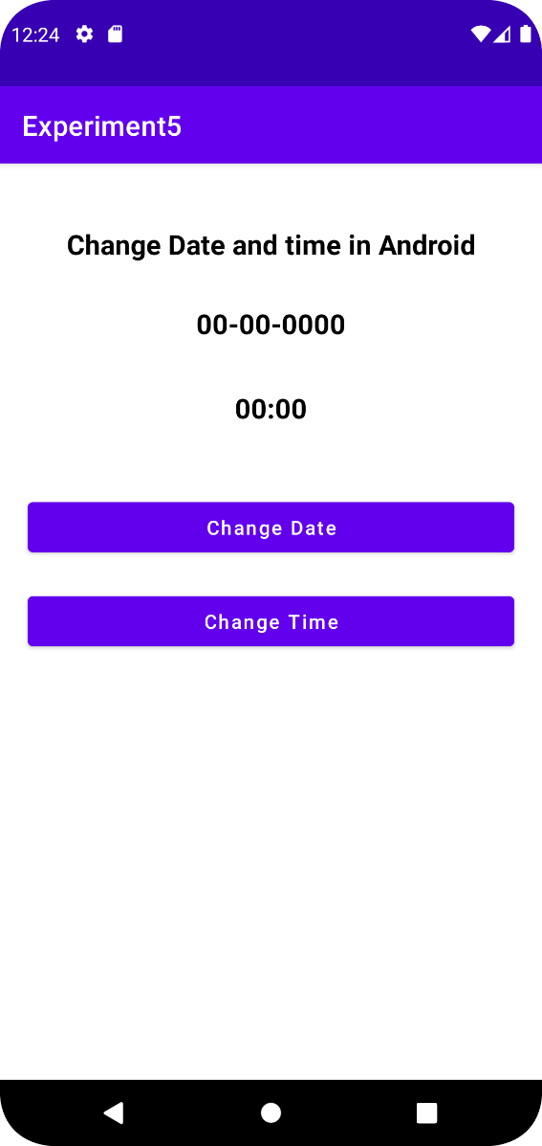

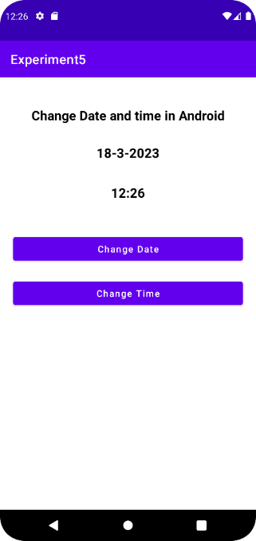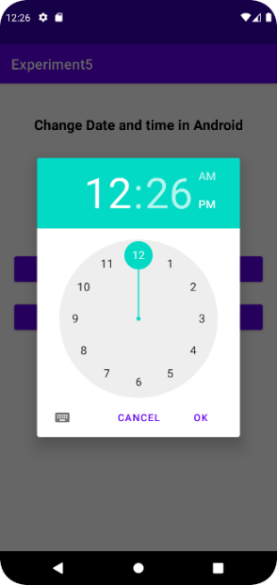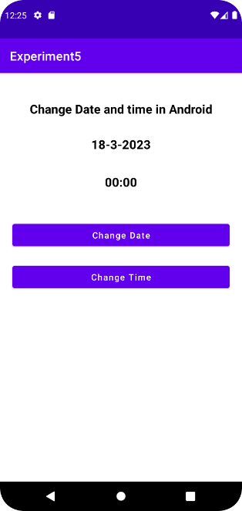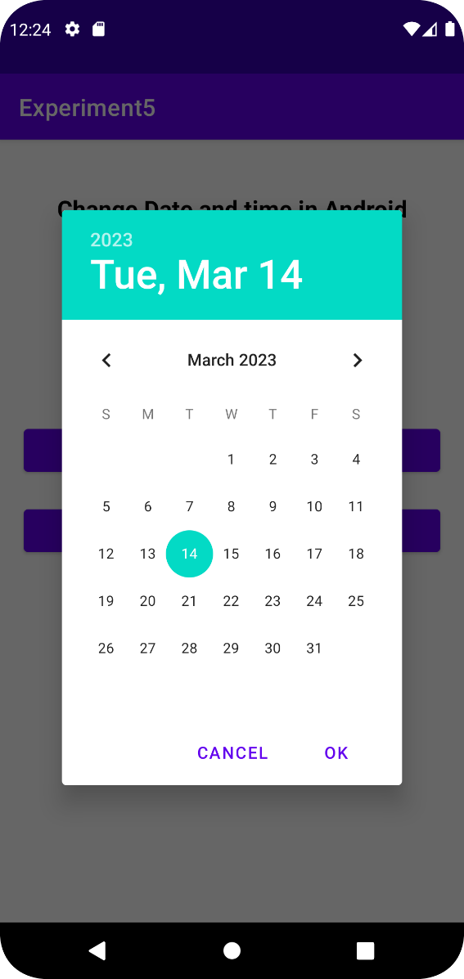

**Result and Discussion:** We successfully implemented a program to implement date and time picker in Android Studio.

**Learning Outcomes:** The student should have the ability to

LO1: explain how a date and time picker can be implemented in Android Studio. LO2: execute a simple program to implement date and time picker in Android Studio

**Course Outcomes:** Upon completion of the course students will be able to to implement date and time picker in Android Studio

# Conclusion:

We understood in this experiment the concept of date and time picker in android studios. Furthermore, the DatePickerDialog class and TimePickerDialog class along with their respective parameters were understood. We implemented program that allows user to pick their date of birth and select a particular time slot. The program was executed on the Android Virtual Device.

For Faculty Use

|  |  |  |  |  |
| --- | --- | --- | --- | --- |
| **Correction Parameters** | **Formative Assessment [40%]** | **Timely completion of Practical [ 40%]** | **Attendance / Learning Attitude [20%]** |  |
| **Marks Obtained** |  |  |  |